Windows 10 Toast Notification Script documentation

Contents

Configuration 2

Toast - Feature 2

UpgradeOS - Feature 2

PendingRebootUptime - Feature 2

PendingRebootCheck - Feature 2

TargetOS 2

MaxUptimeDays 3

PendingRebootUptimeText 3

PendingRebootCheckText 3

Deadline 3

UseSoftwareCenterApp 3

UsePowershellApp 3

CustomAudio 3

ActionButton 3

DismissButton 3

SnoozeButton 4

Scenario 4

Action 4

Installation 4

SCCM 4

Group Policy Preferences 5

Create Files 5

Scheduled Task 6

Intune and other 7

Logging 7

Examples 7

Additional information 8

# Configuration

The script is customizable through the config-toast.xml. The config-toast.xml can be located locally next to the New-ToastNotification.ps1 file or located on a network share.

The script will try to use the file locally if no other path is set in the -Config parameter.

New-ToastNotification.ps1" -Config \\YourPath\ToastNotificationScript\Configs\config-toast-pendingreboot.xml

Setting a remote config file enables you to quickly modify the purpose of the Toast Notification without pushing new files to the computer running the toast. This also enables you to have several configurations, for running multiple purposes. Just point to another configuration when required.

## Toast - Feature

This enables or disables the entire toast notification.

Possible values: True | False

**<Option Name="Toast" Enabled="True" />**

## UpgradeOS - Feature

This enables the toast for use with Windows Servicing. When this is set to True, the build of the running OS is compared with the target OS.

Possible values: True | False

**<Feature Name="UpgradeOS" Enabled="False" />**

## PendingRebootUptime - Feature

This enables the toast for use for checking computer uptime. If this is set to True, the MaxUptimeDays is considered. If toast is displayed if the MaxUptimeDays is exceeded.

Possible values: True | False

**<Feature Name="PendingRebootUptime" Enabled="False" />**

## PendingRebootCheck - Feature

This enables the toast for use for checking for pending reboots.

Pending reboots are checked in WMI and registry. The toast is displayed if pending reboots are found. WMI is only checked if the computer where the toast is running has the SCCM client installed.

Possible values: True | False

**<Feature Name="PendingRebootCheck" Enabled="True" />**

## TargetOS

This sets the expected target OS build when running the toast with the UpgradeOS feature. This is to prevent the toast from displaying on computers already upgraded to the target OS. No need to remind users of an upgrade they already completed.

Possible values: 18351 = 1903 | 17763 = 1809

**<Option Name="TargetOS" Build="18351" />**

## MaxUptimeDays

When using the toast for checking for pending reboots, the value of this option is also evaluated. If the uptime of the computer exceeds the value set in this option, the toast will be displayed. This option is only considered when having PendingRebootCheck set to Enabled.

**<Option Name="MaxUptimeDays" Value="-1" />**

## PendingRebootUptimeText

This option adds an additional group with text about the uptime of the computer.

Possible values: True | False

**<Option Name="PendingRebootUptimeText" Enabled="False"**

## PendingRebootCheckText

This option adds an additional group with text about the pending reboot in registry/WMI.

Possible values: True | False

**<Option Name="PendingRebootCheckText" Enabled="False"**

## Deadline

Adds an additional group with text containing information about a potential deadline.

**<Option Name="Deadline" Enabled="False" Value="5 June 2019" />**

## UseSoftwareCenterApp

This option set the app doing the toast notification to Software Center. This should only be used, if the computer has the SCCM client installed.

**<Option Name="UseSoftwareCenterApp" Enabled="True" />**

## UsePowershellApp

This option set the app doing the toast notification to Powershell. Use this option, if the computer running the toast doesn't have the SCCM client installed.

**<Option Name="UsePowershellApp" Enabled="False" />**

## CustomAudio

This option adds custom audio to the toast notification. The text set in the config.xml will be read aloud following the actual toast notification.

**<Option Name="CustomAudio" Enabled="False" TextToSpeech="" />**

## ActionButton

Enables or disables the action button. Also sets the name displayed on the button.

**<Option Name="ActionButton" Enabled="True" Value="Understood" />**

## DismissButton

Enables or disables the dismiss button. Also sets the name displayed on the button.

**<Option Name="DismissButton" Enabled="True" Value="Not now" />**

## SnoozeButton

Enables or disables the snooze button. Also sets the name displayed on the button. Enabling this button always displays all 3 buttons.

**<Option Name="SnoozeButton" Enabled="True" Value="Snooze" />**

## Scenario

This option controls how long the toast notification is displayed. Reminder is displayed until the user dismisses the toast. Short is about 5 seconds. Long is about 25 seconds.

Possible values are: reminder | short | long

**<Option Name="Scenario" Type="reminder" />**

## Action

This option sets the action for the action button. There are limited possibilities here. One option being is launching Software Center going directly to an available application.

**<Option Name="Action" Value="softwarecenter:SoftwareID=ScopeId_A9117680-D054-482B-BC97-532E6CBD0E6B/Application_4920c244-5b1e-4434-9117-fded57f5c80f" />**

# Installation

## SCCM

The easiest approach is to run this directly from SCCM using a package. In this scenario, there is no need to copy down any files locally to the computer.

* Simply create a package containing all the files as source files. You can leave out the config.xml and point this to an UNC path to avoid updating DPs every time you need to change the config.xml
* Create a program running powershell and the New-ToastNotification.ps1

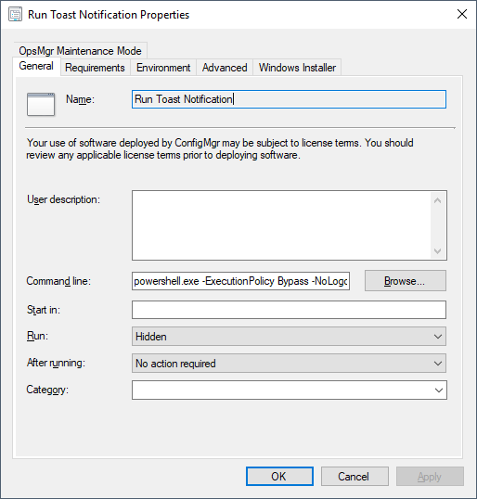

Command line example: powershell.exe -ExecutionPolicy Bypass -NoLogo -NonInteractive -NoProfile -WindowStyle Hidden -File .\New-ToastNotification.ps1 -Config "\\YourUNCPath\ToastNotificationScript\Configs\config-toast-pendingreboot.xml"

## Group Policy Preferences

### Create Files

You can also use GPP to both create a scheduled task and copy the files down locally. I suggest that the files exist locally when using this approach to avoid being dependent on network connectivity.

In this scenario, you create new files locally using Group Policy Preferences. Point to the source files, which should be a network path and point to the destination path, which should be a local path. This needs to be done for each file you need to have locally.

Source: \\YourFileShare\ToastNotificationScript\PendingReboot\New-ToastNotification.ps1

Destination: C:\ProgramData\ToastNotificationScript\PendingReboot\New-ToastNotification.ps1

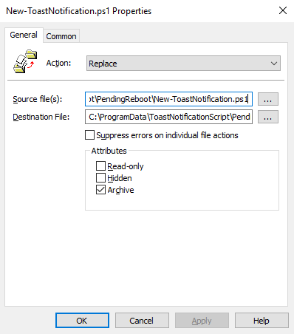

### Scheduled Task

Create a new scheduled task, running in the logged on users context.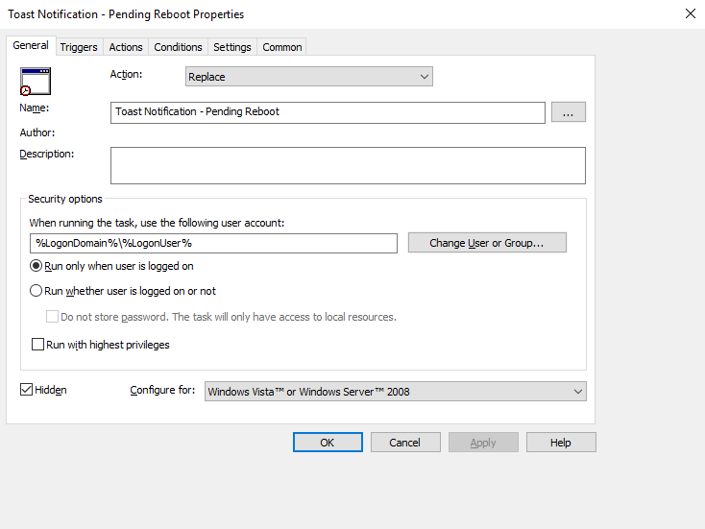

If you want the scheduled task to run completely silent, you will need to make use of 2 additional files which I also included in the download; Hidden.vbs and RunToastHidden.cmd

This is due to the nature of Powershell being a console application and the task running as the logged on user. Simply selecting Hidden and running Powershell.exe hidden is not enough.

Program/script: wscript.exe

Arguments: "C:\ProgramData\ToastNotificationScript\PendingReboot\Hidden.vbs" "C:\ProgramData\ToastNotificationScript\PendingReboot\RunToastHidden.cmd"

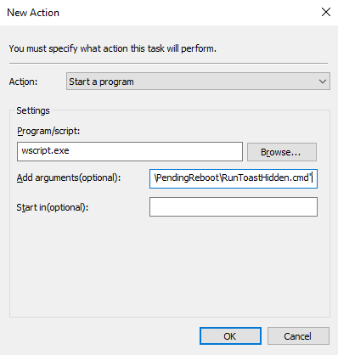

## Intune and other

If you want to use Intune for distributing the toast notification script and the required files, I suggest that you package everything into a .MSI/.EXE file using your favorite packaging installer tool such as Advanced Installer or similar.

# Logging

All actions regarding the toast notification are logged to C:\ProgramData\ToastNotificationScript\New-ToastNotification.log

This is useful when troubleshooting issues or if curious to get a better understanding of what is done.

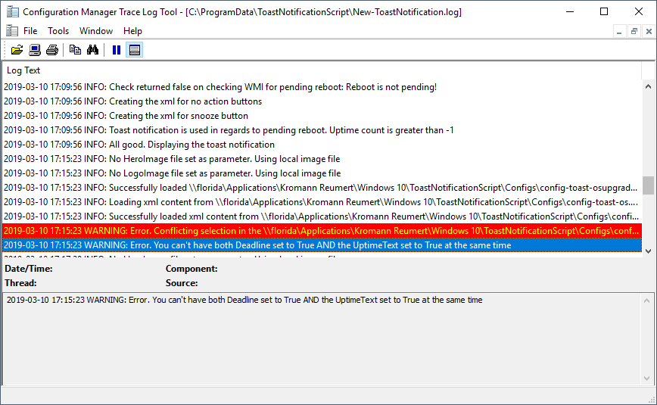

# Examples

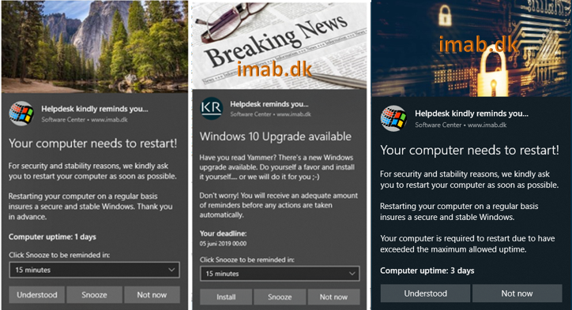

# Additional information

Author: Martin Bengtsson  
Blog: [www.imab.dk](http://www.imab.dk)  
Twitter: @mwbengtsson  
Version: 1.1  
Date: 11 March 2019  
Updated: 21 March 2019